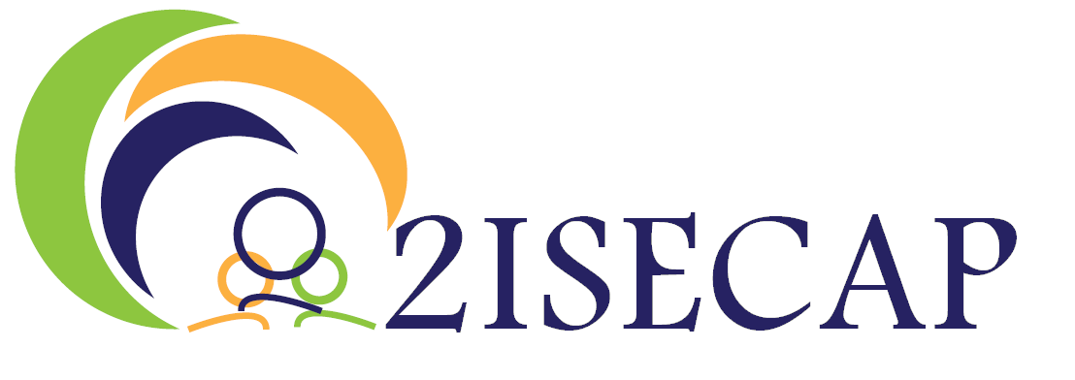

**MEMORANDUM OF UNDERSTANDING**

**Transnational Living Lab**

**Co-Creating the Energy Transition & Climate Actions**

*«Joining forces to boost energy transition in cities and communities in the EU»*

**PROJECT ACRONYM: 2ISECAP**

**PROJECT START DATE**: 01.09.2021 **DURATION:** 36 months

|  |  |
| --- | --- |
| http://europa.eu/about-eu/basic-information/symbols/images/flag_yellow_high.jpg | **“This project has received funding from the European Union’s Horizon 2020 research and innovation programme Euratom research and training programme H2020-LC-SC3-2018-2019-2020 under grant agreement No 101033752 - 2ISECAP.”** |

**MEMORANDUM OF UNDERSTANDING**

**Transnational Living Lab**

**Co-Creating the Energy Transition & Climate Actions**

***«Joining forces to boost energy transition in cities and communities in the EU»***

We, decision makers at all levels of government together with organisations and networks of cities and communities of all sizes, enterprises and individuals, believe that strong cooperation through multi-level governance in the EU and co-creation with citizens are key to our mission of turning our cities and communities into sustainable places where people enjoy living and working. We aim for a cohesive, sustainable Europe, where every community can enjoy the economic and social benefits of this transformation.

At a time when our cities and communities are faced with a growing range of challenges, this MoU to develop a Transnational Living Lab marks an important step in the launch of the «European good practice» of sustainability, transforming cities and communities and boosting energy transition.

The extensive uptake and scaling up of tools and solutions for reducing environmental footprint, increasing energy efficiency and renewable, reuse and recycle resources are crucial to help our cities and communities meet energy transition and climate neutrality. It will also encourage citizen participation, and help all types of businesses, including SMEs and start-ups, to prosper. It is time for all levels of government in the EU to join forces to scale up their sustainability solutions. Encouraging the use of commonly agreed solutions among regions, cities and communities will help reduce inequalities towards a stronger territorial cohesion.

Cooperation across geographical areas and between sectors will boost innovation and allow cities and communities to develop efficient, cost-effective and citizen-centric services. Therefore, the deployment and scaling up of open, interoperable, cross-sector and cross-border platforms as a means to boost energy transition is at the heart of this MoU.

THE SIGNATORIES AGREE ON THE FOLLOWING PRINCIPLES:

* A citizen-centric approach
* A city-led approach at EU level
* The city as a citizen-driven and open innovation ecosystem
* Ethical and socially responsible access, use, sharing and management of data
* Technologies as key enablers

THE SIGNATORIES COMMIT TO DEVELOP TOGETHER A TRANSNATIONAL LIVING LAB AIMING TO CO-CREATE AND BUILD CAPACITY TO SUPPORT SUSTAINABLE MEASURES IN THE FOLLOWING ASPECTS IN ORDER TO:

*FINANCIAL*

* Contribute on a voluntary basis to a joint investment plan to adopt and implement common solutions towards energy transition on a large scale in the EU
* Optimise synergies between EU, national, regional and local funds
* Strengthen investment in energy transition from EU funds and programs, to ensure an inclusive and sustainable Europe
* Use common public procurement practices to jointly define specifications and reduce the cost of investing in energy transition

*TECHNICAL*

* Make key enablers of energy transition — including data, infrastructure and services — available to all
* Use a common platform / portal to share data, services and solutions among cities and communities

*LEGAL*

* Assess the legislative measures needed to provide a common EU framework for cross-sector and cross-border energy transition to cities and communities

*EDUCATION AND CAPACITY BUILDING*

* Develop citizen-centric design approaches as a new competence for policy-making
* Identify new skills needed by public authorities and businesses, and take action to ensure that people acquire these skills
* Provide to the public education and skills needed to benefit from energy transition solutions and to participate in decision making
* Develop a culture of having a co-creative, participative and cross-sector approach to design and implement energy transition solutions
* Facilitate and coordinate activities including knowledge sharing, communication, dissemination and consultancy provision, to scale up successful energy transition
* Take advantage of opportunities that can accelerate deployment

*MONITORING AND MEASURING*

* + Help develop and implement a framework, built on existing methodologies, to measure and monitor the benefits for citizens, public authorities, businesses and other stakeholders at local level

A multi-level governance steering board will be set up in the first quarter of 2024 to progress on the above commitments and ensure that they are delivered by 2025. This steering board will join forces and resources and will improve stakeholder dialogue and collaboration in order to boost the sustainable transformation of cities and communities.

Representative of:

First name and surname:

Position:

Signature:

Date: