Padova 2030 climate neutral - information campaign
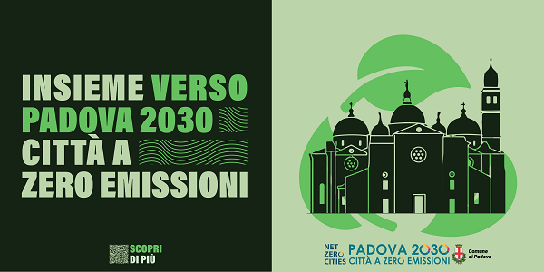
In December 2023, the City of Padova launched an information campaign, which appeared on city billboards and on some streetcar shelters, to raise awareness of the city's path toward decarbonization. The message chosen for the initiative was "Together towards Padova 2030, a zero-emission city," designed to make the participatory dimension of the project and involve all citizens in this ambitious challenge, which, to be won, needs everyone's contribution and commitment.

